Welcome to Global Top Navigation Menu

Simpler way to have a Global Navigation bar in you SharePoint infrastructure

Table of Contents

1. Introduction 2

2. Solution Architecture 3

ASP.NET Pages 3

ASP.NET User Controls 4

Style Sheets 6

Data 7

XMLGlobalNav.xml 7

XMLGroupNames.xml 8

XMLLogs 8

3. Installation 9

4. How to configure it 11

Add Site to the Global Top Menu or/and Footer 12

See Site Information 13

See Site Security 14

Add Custom Group or/and Subgroup 14

Add External Links 15

# Introduction

One of the challenges in SharePoint had been to setup the site top navigation in a way can be easier to maintain and can be a standard navigation cross sub sites and site collection in a web application. SharePoint has Out Of The Box (OOTB) navigation at site collection level. The OOTB navigation is easier to setup however you need to manually synchronize it in all site collections that your web application has which it is going a tedious work to do. Also you can develop a few lines of code to update the navigation in all site collections and sub sites but still is something that you need to run manually or have a job or something to run the piece of code.

Global Top Menu and Footer Navigation will help you to maintain the top navigation bar in one place and have a standard cross all sub sites and site collection without run or manually synchronized it.

Site Collection Administrators are the only ones that have control of what is going to be in the Global Top Menu and Footer. The only option Site Owners can change in the Top Navigation bar is the last option which always will be the name of the site where user is visited.

The options in the Global Top Menu and Footer is Security trimming. Users can see only what they have access.

In the next section will explain how the solution is designed and explain all pieces that play a role in Global Top Menu and Footer Navigation.

# Solution Architecture



Global Top Menu Navigation and Footer solution is a simple solution. This solution was wrote in C# and ASP.NET technology. This solution is one layer only and has four main components.

## ASP.NET Pages

ASP.NET pages are used to load user controls only. This pages are load inside a SP.UI.ModalDialog as Dialog modal window. The solution has the following pages:

* Settings.aspx. This page loads the Setting user control called ucSettings.ascx which will allow users to maintain Global Top Menu Navigation and Footer options. For more information about ucSettings.ascx control click here. This page can be found in /14/template/layouts/SP.GlobalTopMenu/ folder.

## ASP.NET User Controls

All user controls are designed to be easier maintain and modified according to the needs of the user. Please be aware that there is part of the controls you should not touch. All user controls use in one way or another [jquery](http://jquery.com/) and [jquery ui](http://jqueryui.com/) frameworks. The solution has the following user controls:

* ucBreadcrumb.ascx. The propose of this control is to show a breadcrumb in the navigation feature. By default this is called inside ucGlobalNav.ascx user control. However you can remove from there and add anywhere else you like according to your site design.

This control uses [xbreadcrumbs](http://www.ajaxblender.com/xbreadcrumbs.html) to render the information and uses PortalSiteMapProvider.CurrentNavSiteMapProviderNoEncode to get all the data from SharePoint breadcrumb navigation. For more information about CurrentNavSiteProviderNoencode see [MSDN](http://msdn.microsoft.com/en-us/library/microsoft.sharepoint.publishing.navigation.portalsitemapprovider.currentnavsitemapprovidernoencode.aspx)

All the structure of the xbreadcrumbs will be created by the code behind dynamically.

The user control looks like the image below. You have flexibility to change the style such color, fonts, position on so on. The style name is xbreadcrumbs.css and is located in 14\template\layouts\SP.GlobalTopMenu\css\ folder. For more information about xbreadcrumbs.css click here

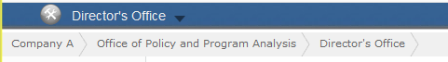

* ucGlobalFooter.ascx. The propose of this control is to create a footer dynamically by taking the settings defined by user using the ucSettings user control. This footer has two rows the first one is dynamically created and the second can be static by added it inside the control itself.

The user control looks like the image below. You have flexibility to change the style such color, fonts, position and so on. The style name is Footer.css and is located in 14\template\layouts\SP.GlobalTopMenu\css\ folder. For more information click



* ucGlobalNav.ascx. The propose of this control is to create a Global Navigation bar cross sub sites and site collections. The Global Top Menu Navigation control will allowed to have three columns and 7 rows by column. This control has three parts.

Site owner option

Settings option

Standard options



***Settings option****.* This is the first option in the Global Top Menu and it is able/visible only to Site Collection Administrator. This button popup the setting windows where Site Collection Administrators can maintain the standard option cross sub sites or site collections.

options in the Global Top Menu and Footer is Security trimming. Users can see only what they have access

***Standard options.*** All options defined by the site collection administrators. These option cannot be modified by site owner nor contributors. These options are taken from the xml files (XMLGlobalNav and XMLGroupNames)

***Site owner option.*** These is the only option site owner can modified. Site owner can add or remove options by update Settings/Navigation information. This option includes information from the Global Navigation Group and sub sites titles of the current site. Site owner can create groups and add items in the groups. (See image below)

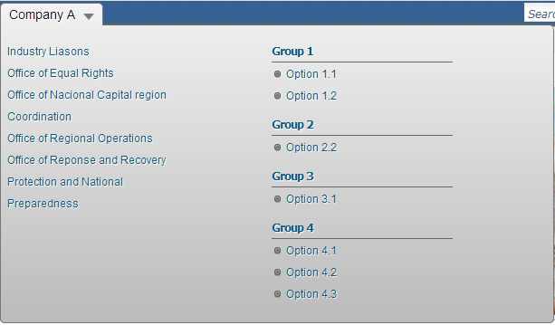

* ucSettings.ascx. The propose of this control is allowed to the site collection administrators to manage the Global Top menu and footer options (see “How to configure it”).

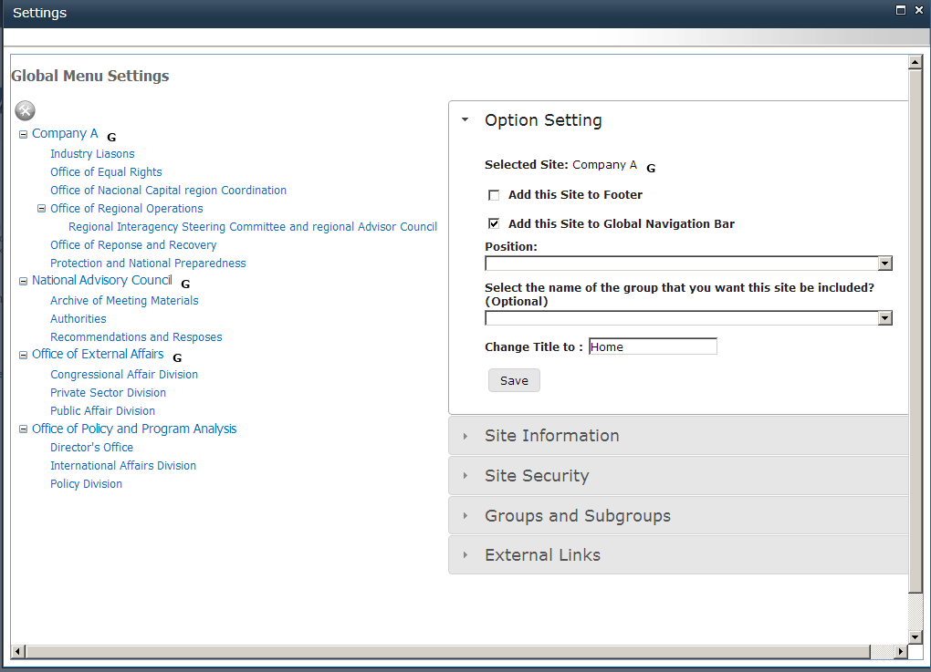

## Style Sheets

The Look and feel is totally flexible, you can modify color, font, width, and so on. Each user control has a separated css file, this helps to maintain the look and feel encapsulated. All css files are simple to read and modify. The list below show all the css files for each component in the solution. Before make any change in the css files, the recommendation is to make copy and have a backup just in case something comes wrong.

|  |  |
| --- | --- |
| Css File | Description |
| xbreadcrumbs.css | ucBreadcrumb.ascx is a UL/IL structure that is nicely display by using this css file. If you want to change how the breadcrumb looks like you need to change this css file. |
| Footer.css | ucGlobalFooter.ascx is a UL/IL structure that is nicely display by using this css file. If you want to change how the breadcrumb looks like you need to change this css file. |
| jquery-ui.css | Please visit jquery ui web site for more information. |
| Menu.css | ucGlobalNav.ascx is a UL/IL structure that is nicely display by using this css file. If you want to change how the breadcrumb looks like you need to change this css file. |
| Settings.css | ucSettings.ascx is a UL/IL structure that is nicely display by using this css file. If you want to change how the breadcrumb looks like you need to change this css file. |

## Data

XMLGlobalNav.xml. This xml file saves all the navigation structure. The recommendation is do not modified it. This file is updated by the solution and you should be careful if you need to make any change. This files has the following information:

|  |  |  |
| --- | --- | --- |
| Name | Description | Notes |
| SiteId | Site Collection or Sub Site GUID. |  |
| SiteTitle | Site Collection or Sub Site Title |  |
| NewTitle | If user decided to change the default title of the site to a new title, this will save in this tag. | This change will be not reflected in the Site itself. This new title will be only for Global Top Menu and Footer propose. |
| SiteDescription | Short description will be used as Tooltip in the Global Top Menu. |  |
| SiteUrl | Relative URL of the Site Collection or Sub site. |  |
| Position | Order of the option in the Global Top Menu and Footer. This order will depended where the option is located. |  |
| GroupId | Group Id where the option should be inserted. | The group Id is coming from the XMLGroupName.xml file. You can have custom groups. (See XMLGroupName.xml) |
| GlobalNav | * If value is TRUE, this option will be added to the Global Top Menu. * If value is FALSE, this option will not be added to the Global Top Menu. |  |
| Footer | * If value is TRUE, this option will be added to the Footer. * If value is FALSE, this option will not be added to the Footer. |  |
| ExternalLnk | * If value is TRUE, this option is an external link. * If value is FALSE, this option is not an external link. | External Link can be a Document link, a web site outside SharePoint infrastructure, and so on. This is pretty much a flexible way to add links. |
| ParentId | Site Collection or Sub Site GUID of the Site Parent. | If there is value in this tag the Global Top Menu will insert this option under a group with the Parent Title as name. This will be overwrote if you have a value in the GroupId tag. |

Example:

<?xml version="1.0" encoding="utf-8"?>

<GlobalNav>

<Item>

<SiteId>484794a2-0870-45e9-8bb2-bf6e0dd095bb</SiteId>

<SiteTitle>Office of Financial Management</SiteTitle>

<NewTitle></NewTitle>

<SiteDescription></SiteDescription>

<SiteUrl>/OAM/OFM</SiteUrl>

<Position>0</Position>

<GroupId>0</GroupId>

<GlobalNav>True</GlobalNav>

<Footer>False</Footer>

<ExternalLnk>false</ExternalLnk>

<ParentId>8c6097ef-003e-4d0a-90c8-3c3527877eed</ParentId>

</Item>

</GlobalNav>

XMLGroupNames.xml. This xml file saves all custom groups of the Global Top Menu. The recommendation is do not modified it. This file is updated by the solution and you should be careful if you need to make any change. This files has the following information:

|  |  |
| --- | --- |
| Name | Description |
| Id | Custom Group GUID. |
| Name | Custom Group Title |
| Description | Short description will be used as Tooltip in the Global Top Menu. |
| Position | Order of the option in the Global Top Menu and Footer. This order will depended where the option is located. |
| ParentId | Group Id that is parent of the Group. |

<?xml version="1.0" encoding="utf-8"?>

<GroupNames>

<Group>

<Id>09273485-257d-4714-93cc-5c6db13fe10b</Id>

<Name>sdsdsd</Name>

<Description></Description>

<Position></Position>

<ParentId></ParentId>

</Group>

</GroupNames>

XMLLogs. This xml file saves all errors of the Global Top Menu. The recommendation is do not modified it. This file is updated by the solution and you should be careful if you need to make any change. This files has the following information:

|  |  |
| --- | --- |
| Name | Description |
| ErrorId | Error GUID. |
| Message | Error Message |
| StackTrace | Stack trace of the error |
| InnerException | Extra information of the error. |
| TargetSite | Method that throws the error. |

# Installation

1. Download wsp file from Codeplex ([SPGlobalTopMenuNav](https://spglobaltopmenunav.codeplex.com/)).
2. Install SharePoint Solution.
3. Create a Document Library in the Root Site Collection (eg. http://hostname). The Document Library name must be SPGlobalTopMenu. The solution will be used this Document library to save configuration of the Global Top Menu and Footer included images and options' information.
4. Add Global Top Menu and Footer in the Master Page.
5. Go to the top of the Master Page and register the user controls

*This user control is for the Top Menu*

<%@ Register TagPrefix="GTM"

TagName="GlobalNavigation"

src="~/_controltemplates/SP.GlobalTopMenu/ucGlobalNav.ascx" %>

*This user control is for the Footer*

<%@ Register TagPrefix="GTF"

TagName="GlobalFooter"

src="~/_controltemplates/SP.GlobalTopMenu/ucGlobalFooter.ascx" %>

1. Find PlaceHolderHorizontalNav and do the following

Add <GTM:GlobalNavigation ID="GlobalNavigation1" AddUrl="true" runat="server"/>after <asp:ContentPlaceHolder id="PlaceHolderHorizontalNav" runat="server">

1. Find TopNavigationMenuV4 and set Visible="false"
2. Find TopNavigationDataSource and set Visible=false
3. Add <GTF:GlobalFooter ID="GlobalFooter1" runat="server"/> before <SharePoint:DeveloperDashboard runat="server"/>

After changes your code should looks like the follow:

<asp:ContentPlaceHolder id="PlaceHolderHorizontalNav" runat="server">

<GTM:GlobalNavigation ID="GlobalNavigation1" AddUrl="true" runat="server"/>

<SharePoint:AspMenu

ID="TopNavigationMenuV4" Visible="false"

Runat="server"

EnableViewState="false"

DataSourceID="topSiteMap"

AccessKey="<%$Resources:wss,navigation_accesskey%>"

UseSimpleRendering="true"

UseSeparateCss="false"

Orientation="Horizontal"

StaticDisplayLevels="2"

MaximumDynamicDisplayLevels="1"

SkipLinkText=""

CssClass="s4-tn"/>

<SharePoint:DelegateControl runat="server" ControlId="TopNavigationDataSource"

Id="topNavigationDelegate" Visible="false">

<Template_Controls>

<asp:SiteMapDataSource

ShowStartingNode="False"

SiteMapProvider="SPNavigationProvider"

id="topSiteMap"

runat="server"

StartingNodeUrl="sid:1002"/>

</Template_Controls>

</SharePoint:DelegateControl>

</asp:ContentPlaceHolder>

SharePoint runs specific JavaScript scripts that affect ContentPlaceHolders such as PlaceHolderTopNavBar. This script will not allow the Global Top Menu to be rendered in the Form and setting pages. If you want to have the same navigation bar on the setting pages, you need to do the following steps:

* + 1. Find PlaceHolderTopNavBar and rename to PlaceHolderTopNavBarArea.
    2. Find PlaceHolderHorizontalNav and rename to PlaceHolderHorizontalNavArea
    3. Copy this div before PlaceHolderTopNavBarArea

<div style="display:none">

<asp:ContentPlaceHolder id="PlaceHolderTopNavBar" runat="server">

<asp:ContentPlaceHolder id="PlaceHolderHorizontalNav" runat="server">

</asp:ContentPlaceHolder>

</asp:ContentPlaceHolder>

</div>

* + 1. After all changes made, you should have something that looks like

<!—Default ContentPlaceHolder hidden -->

<div style="display:none">

<asp:ContentPlaceHolder id="PlaceHolderTopNavBar" runat="server">

<asp:ContentPlaceHolder id="PlaceHolderHorizontalNav" runat="server">

</asp:ContentPlaceHolder>

</asp:ContentPlaceHolder

</div>

<!—rename Default ContentPlaceHolders-->

<asp:ContentPlaceHolder id="PlaceHolderTopNavBarArea" runat="server">

<asp:ContentPlaceHolder id="PlaceHolderHorizontalNavArea" runat="server">

<GTM:GlobalNavigation ID="GlobalNavigation1" AddUrl="true" runat="server"/>

<SharePoint:AspMenu

ID="TopNavigationMenuV4" Visible="false"

Runat="server"

EnableViewState="false"

DataSourceID="topSiteMap"

AccessKey="<%$Resources:wss,navigation_accesskey%>"

UseSimpleRendering="true"

UseSeparateCss="false"

Orientation="Horizontal"

StaticDisplayLevels="2"

MaximumDynamicDisplayLevels="1"

SkipLinkText=""

CssClass="s4-tn"/>

<SharePoint:DelegateControl runat="server" ControlId="TopNavigationDataSource" Id="topNavigationDelegate" Visible="false">

<Template_Controls>

<asp:SiteMapDataSource

ShowStartingNode="False"

SiteMapProvider="SPNavigationProvider"

id="topSiteMap"

runat="server"

StartingNodeUrl="sid:1002"/>

</Template_Controls>

</SharePoint:DelegateControl>

</asp:ContentPlaceHolder>

</asp:ContentPlaceHolder>

# How to configure it

Global Top Menu and Footer can be maintained by using the setting page. In this page you can work with options, groups, order of the groups and options, external links, and see extra information of the sites such as Security, general information and so on.

Setting page has two main panels: List of Site Collections, Sub Sites and External Links and Collapsible Menu. (See image below)

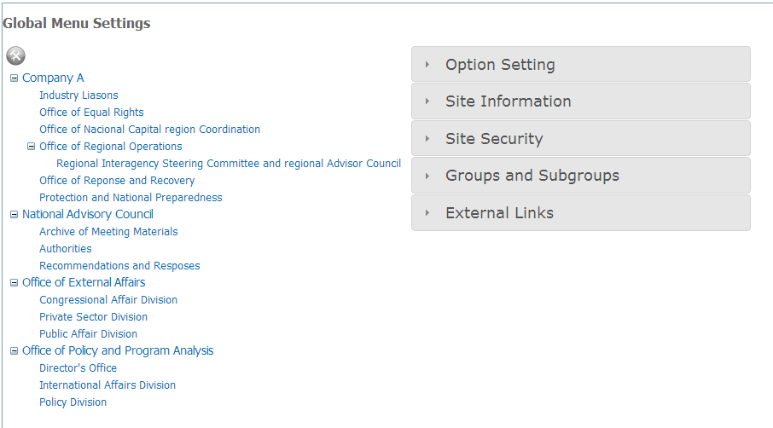

Collapsible Menu

List of Site Collections, Sub Sites and External Links

In the *List of Site Collections, Sub Sites and External Link*, you can select and check what options are in the Global Top Menu and Footer (see image below)

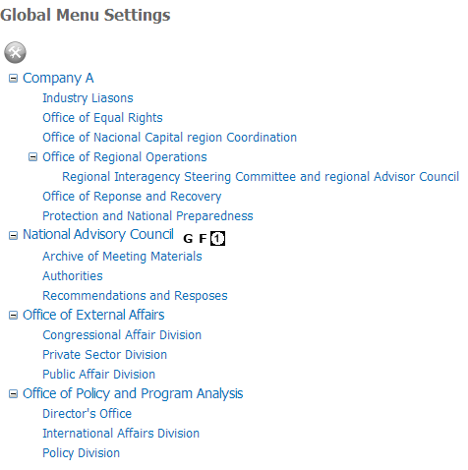

Position

Added to the Footer

Added to the Global Top Menu



In the *Collapsible Menu* has five options. (See Table below)

|  |  |
| --- | --- |
| Options | Description |
| Option Setting | Allows users to add, remove, rename, set position and set group for the selected Site Collection or Sub Site. This option is only applicable for Site Collections and Sub Sites. |
| Site Information | Show general information of the selected Site Collection or Sub Site such as Description, Custom Master Url, Alternate Css Url, Has Unique Permissions and Settings Page. This option is only applicable for Site Collections and Sub Sites. |
| Site Security | Show security information such as User Name or Group, Login Name, member of, and Site Administrator? |
| Group and Subgroups | Allows users to add, edit, and remove Groups and subgroups. |
| External Links | Allows users to add, remove, and edit External links. You can add the external link to Global Top Menu or/and Footer by checking the box. |

## Add Site to the Global Top Menu or/and Footer

1. Click setting icon  to get the setting page.
2. Select Site Collection or Sub site on the List of Site Collection and Sub sites. You should see the name of the site on the “Option Settings” panel. (See Image below)

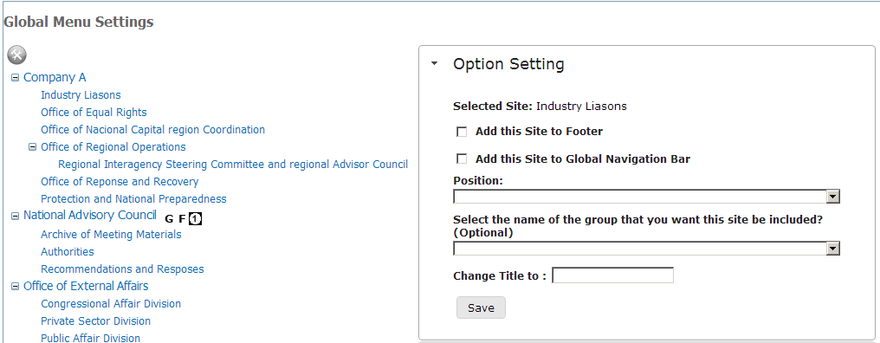

1. Check “Add this site to Global Navigation Bar” checkbox if you want to add to the Global Top Menu or/and Check “Add this Site to Footer” checkbox if you want to add it to the footer.
2. (Optional) Choose the position for the selected Site on the “Position” dropdown list. You cannot select the positions that already taken. If you want to take one taken position, you need first to unselect the position from the site and then select it for the one site you want.
3. (Optional)Choose the custom group in the “Select the name of the group that you want this site be included?” dropdown list. (See “Add a Custom Group or Subgroup”)
4. (Optional)If you want to change the title of the selected site, enter the new title inside “Change Title to” text box.
5. Click Save button to save the changes.

## See Site Information

1. Click setting icon  to get the setting page.
2. Select Site Collection or Sub site on the List of Site Collection and Sub sites.
3. Click “Site Information” option in the Collapsible Menu. (See image below)

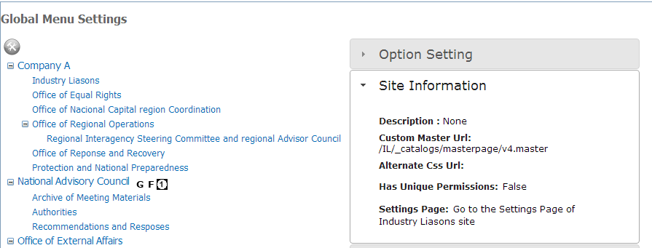

## See Site Security

1. Click setting icon  to get the setting page.
2. Select Site Collection or Sub site on the List of Site Collection and Sub sites.
3. Click “Site Security” option in the Collapsible Menu. (See image below)

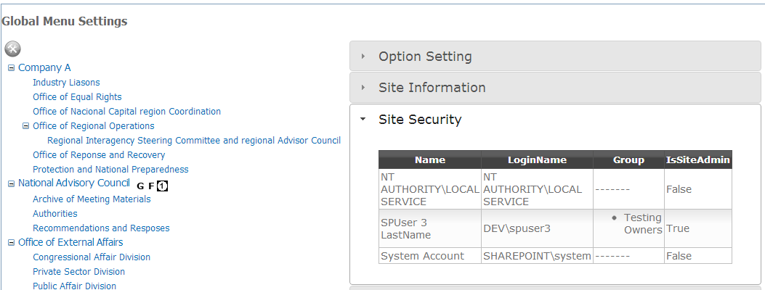

## Add Custom Group or/and Subgroup

1. Click setting icon  to get the setting page.
2. Click “Groups and Subgroups” option in the Collapsible Menu. (See image below)

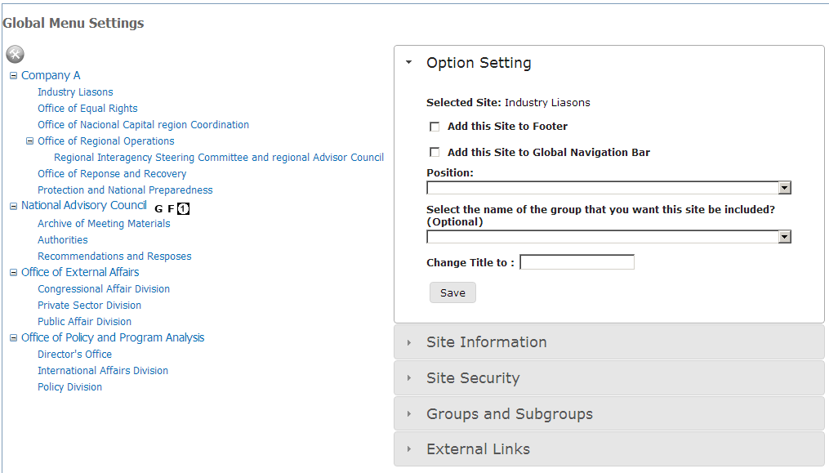

1. Click “Add” button. Enter Title, Description, Position (Optional), and Parent (Optional). (See image below)

Groups will be a Top option in the Top Menu.

Subgroups will show inside Groups.

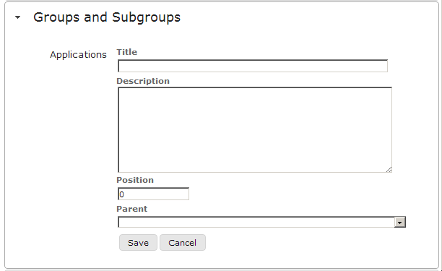

This will show only Parent Groups not subgroups.

Note: If you select a Parent, the group will be a subgroup of the Parent Group.

1. Click “Save” button to save the information.

## Add External Links

1. Click setting icon  to get the setting page
2. Click “External Links” option in the Collapsible Menu. (See image below)



1. Click “Add” button. Enter Title, Url, Description, Position (Optional), “Select the name of the group that you want this site be included?” (Optional), check “Add this site to Footer” checkbox if you want to add it to the footer (Optional), and “Add this site to Global Navigation Bar” checkbox if you want to add it to the Top Menu. (See image below)

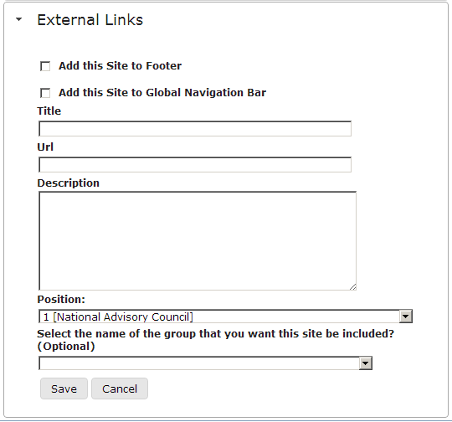

1. Click “Save” button to save the information.